**CP Club 365 Days Challenge**

**Programming language – Python**

**Problem Statement**

<https://www.codechef.com/DSAPREP_01/problems/EXPRESSION_3>

**Your Code**:

# 0x77Day of 0x365Days challenge

# VEDANT BHARAD

# 2-1-2023

t=int(input())

while t>0:

    A,B,C=map(int,input().split())

    v=[A,B,C]

    v.sort()

    if v[2]-(v[1] +v[0])==0:

        print("YES")

    else:

        print("NO")

    t-=1

**Output (Screen Shot)**:

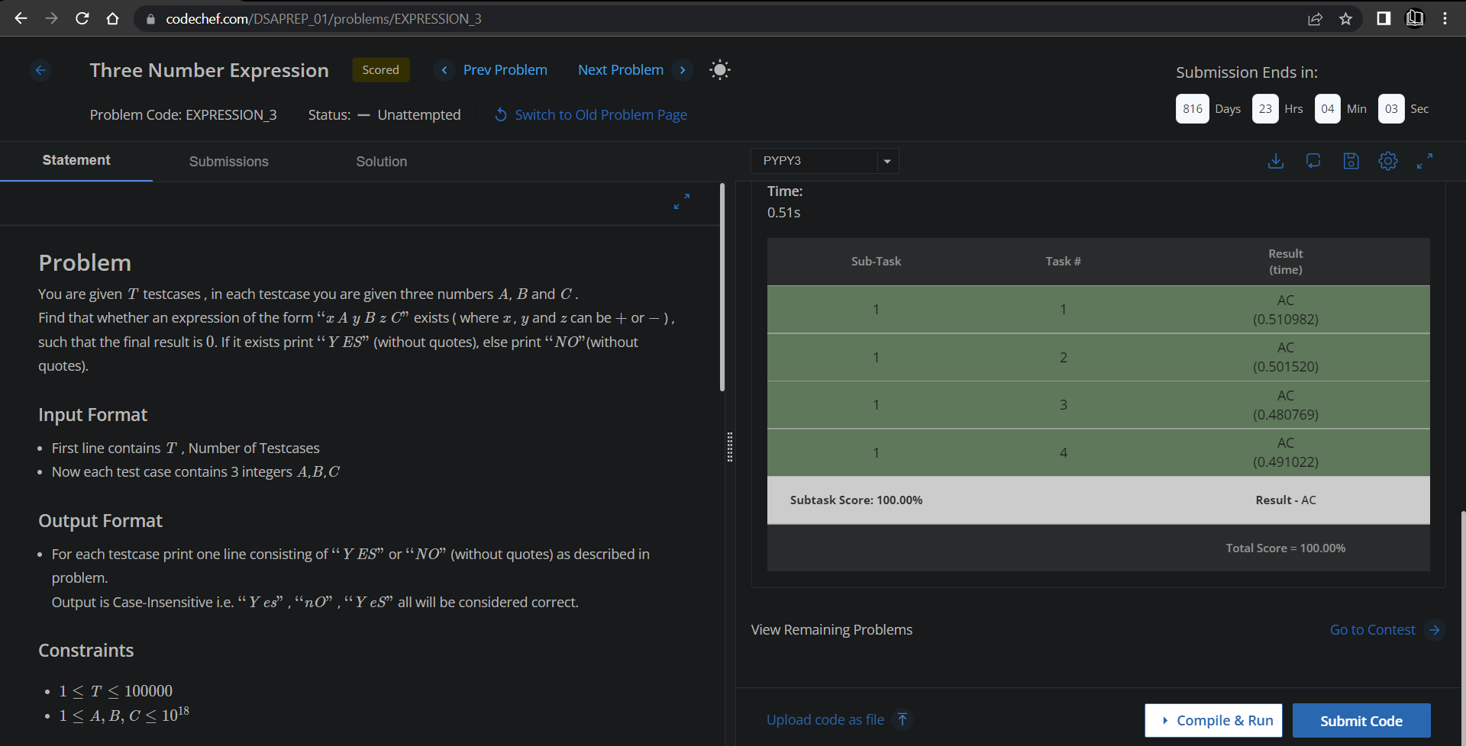

**Understanding about problem:**

* In this task I need find whether an expression of the form “xAyBzC” exists (where x , y and z can be + or - ) , such that the final result is 0 if result is 0 return YES else NO.

Note: If you can't understand the problem, feel free to contact us and we'll help you. Please don't copy and paste from anywhere.

ALL THE BEST

Team CP Club